ERAU FACULTY & STAFF CLIMATE SURVEY
SPRING 2009 – OVERALL RESULTS
(Produced by the offices of Human Resources and Institutional Research, March 2009)

Administration

In preparation for the eighth administration of the Climate Survey in Spring 2009, the previous year’s survey instrument was reviewed by Human Resources, Institutional Research, and the Cabinet. As a result, 5 items were reworded. The survey remained a web-based instrument, with 31 “agreement” items (5-point scale: Strongly Agree to Strongly Disagree), 7 “rating” items (revised 5-point scale: Very Good to Very Poor), 6 demographic items, and 3 open-ended comment boxes.

The survey was conducted from February 2, 2009 through February 23, 2009. An email invitation to participate was sent on February 2 from Human Resources to all ERAU employees, and a reminder message was sent on February 16. All employees were urged to participate, regardless of status, location, etc.
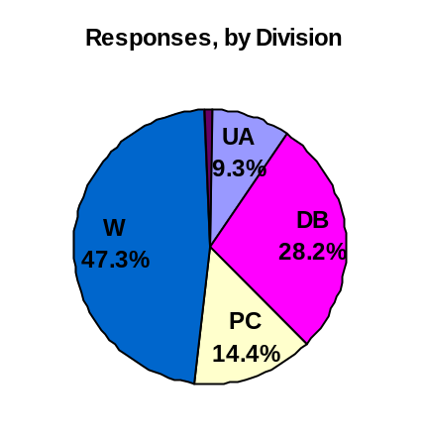
Response Rates

There were a total of 840 responses. This equates to an estimated 29% response rate. Responses by division were as follows:
- University Administration = 79 (34% response rate)
- Daytona Beach Campus = 237 (25% response rate)
- Prescott Campus = 121 (30% response rate)
- Worldwide = 397 (30% response rate)
- Not Indicated = 6

Results

The four charts that follow display the overall results from all divisions combined: one chart for the 31 “agreement” items, one chart for the 7 “rating” items, and 2 charts comparing the results from this survey to the last (as applicable).

In summary, participants responded most positively (91%) to -- “I am proud to be associated with the University”. Furthermore, 17 additional items garnered at least 75% “approval”, to include items reflecting technology, communication, performance feedback and planning, having the materials needed to do the job, attention to diversity issues, and the overall perception that Embry-Riddle is a “good place to work”. 18 items were still rated positively by a majority of respondents, between 50% and 75%. Only two items received less than 50% approval: campuses consideration when budget allocations are made, and pay in comparison to other similar organizations.

When compared to last year’s results 26 items were more positive, including items regarding budget allocations, technology, strategic planning, assessment, Human Resources, overall appearance of the campuses, and hiring women and underrepresented groups. Three of the responses were similar to last year, and the remaining 6 were less positive. Items in this category showed between a 1.1% and 3.1% decrease in agreement, the largest of which were the items regarding ERAU’s major goals and directions, and opportunities to learn and grow, either at work or through professional development activities.

The full report includes breakouts and trends by division (University Administration, Daytona Beach, Prescott, Worldwide Campus), gender, and position (faculty, staff).The full report will be posted on the Institutional Research website. The posted report does not include a listing of the open-ended comments; however, comments will be delivered to select Cabinet members for review and feedback to individuals and/or departments, as appropriate.
